
Topic:- SMART IRRIGATION SYSTEM
Team Members and Roll No. :-
- Prithvi Raj Gupta (25/SET/BCML/126)
- Krish Aggarwal (25/SET/BCML/63)
- Didhi Samiksha (25/SET/BCML/117)
- Satyam Jha (25/SET/BCML/83)
Role of Each Participant:-
- Prithvi Raj Gupta:
- Model assembly
- Writeup
- Krish Aggarwal:
- Model assembly
- Team leader
- Didhi Samiksha:
- Model assembly
- Writeup
- Satyam Jha:
- Model assembly
- Making connections
Professor Name (PHYSICS):- Dr. Sandeep Srivastava Sir
Aim:-
To make Smart Irrigation System using Arduino Uno.

Components Required: -
- Arduino Uno R3 (Type-C)
- Soil Moisture Sensor (Digital Output)
- Relay Module (5V)
- DC Motor/Water Pump (5V/12V)
- Jumper wires
- Breadboard
- External Power Supply (for motor if needed)
- Type C cable
- Hot glue gun
- Cardboard
- Plant pot
- Screw driver
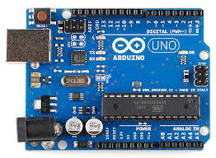
Reference: https://share.google/images/UWlTNxsdRr23lnXXg
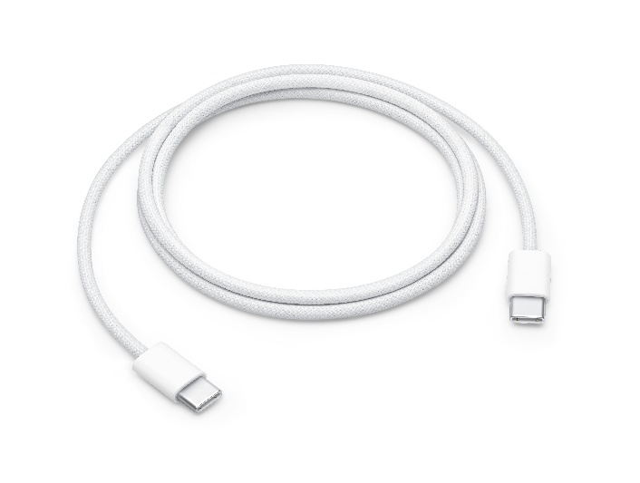
Reference:https://share.google/images/UvmzTiFM1B2YjuM7h

Theory: -
A Smart Irrigation System is an automated watering system that uses sensors and microcontrollers to supply water to plants only when required. Its main principle is soil-moisture-based irrigation, which helps in water conservation and efficient crop growth.

Core Theoretical Concepts: -

- Soil Moisture Sensing
- A soil moisture sensor (capacitive or resistive type) measures the water content of the soil.
- It provides an analog voltage to the Arduino Uno that corresponds to moisture levels:
- Dry soil → High analog value
- Wet soil → Low analog value
- Microcontroller-Based Decision Making
- The Arduino Uno reads the moisture sensor’s analog value through its ADC (Analog-to-Digital Converter).
- Based on a predefined threshold moisture level, the Arduino decides whether irrigation is needed.
- This forms a closed-loop control system.

- Water Pump Control
- A relay module acts as a switch to control a water pump (DC pump/submersible pump).
- When soil moisture falls below threshold → Arduino activates relay → pump ON
- When soil moisture rises above threshold → pump OFF

- Automation + Power Efficiency
- The system eliminates manual watering.
- Prevents over-irrigation and under-irrigation.
- Saves water by supplying it only when necessary.

- Optional Add-Ons (theoretical features)
- Temperature/humidity sensor (DHT11/22)
- Real-time clock (RTC) for time-based control
- GSM module for SMS alerts
- Wi-Fi module (ESP8266) for IoT monitoring
- OLED/LCD display for real-time moisture status

Functions of Materials:-
Pin Connections:
- Soil Moisture Sensor:
- VCC -> 5V
- GND -> GND
- D0 -> Pin 7 (Digital Output)

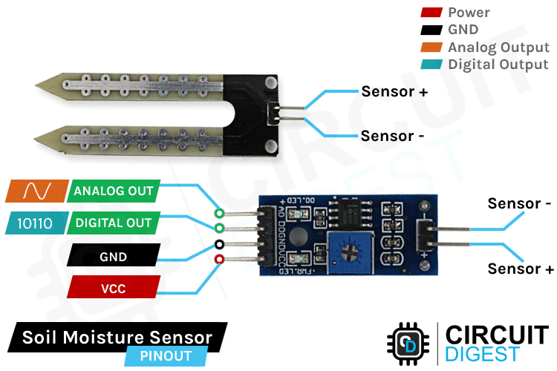

Reference: https://share.google/images/7FMNFSB3X6RInMq8A

- Relay Module:
- VCC -> 5V
- GND -> GND
- IN -> Pin 6 (Control Signal)
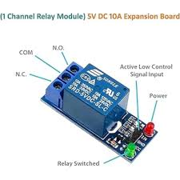Reference:https://share.google/images/YY593TAGZo3HUEM7s

- DC Motor/Pump:
- Connect to Relay COM and NO terminals
- Motor power supply connected through relay

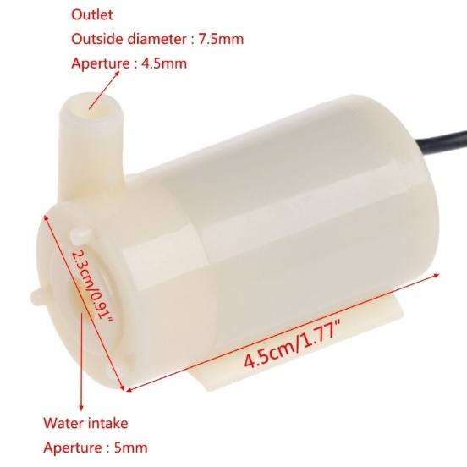
Reference: https://share.google/images/juLShkOtYPqVpqxSV
Construction: -
- Connect 5V to positive rail and GND to negative rail.
- Connect sensor VCC to positive rail and GND to negative rail.
- Single pin D7.
- CONNECT RELAY VCC 5V , GND to GND , single pin-D6.
- Connect jumper wires to mini pump black wire and connect the red wire of mini pump with the ND of single relay.
- Then take another jumper wire and connect it with COM of single relay.
- Now connect the jumper wires attached to single relay, black with negative, red with positive of breadboard.
- Put the code given below in tinkercad.
- Connect the whole model with computer.

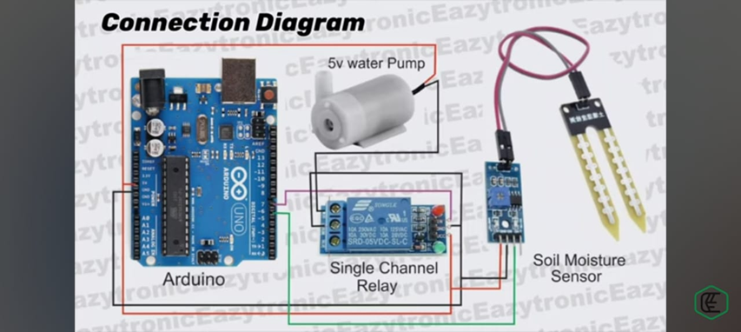
Reference: https://youtu.be/bJIriNF0zcA?si=Pzr6Gw3DD3gJOM4
Block Diagram: -
Soil Moisture Sensor → Arduino Uno → Relay Module → Water Pump → Plant/Field

Feedback: -
Soil moisture updates continuously and regulates the pump.

Working Of System: -
- Soil moisture sensor is placed in the soil.
- Sensor sends continuous moisture data to Arduino.
- Arduino compares the reading with a preset threshold.
- If soil is dry:
→Arduino sends HIGH signal to relay
→Relay switches ON the pump
- Watering continues until moisture reaches the threshold.
- Then Arduino switches OFF the pump.
- Process keeps repeating automatically.
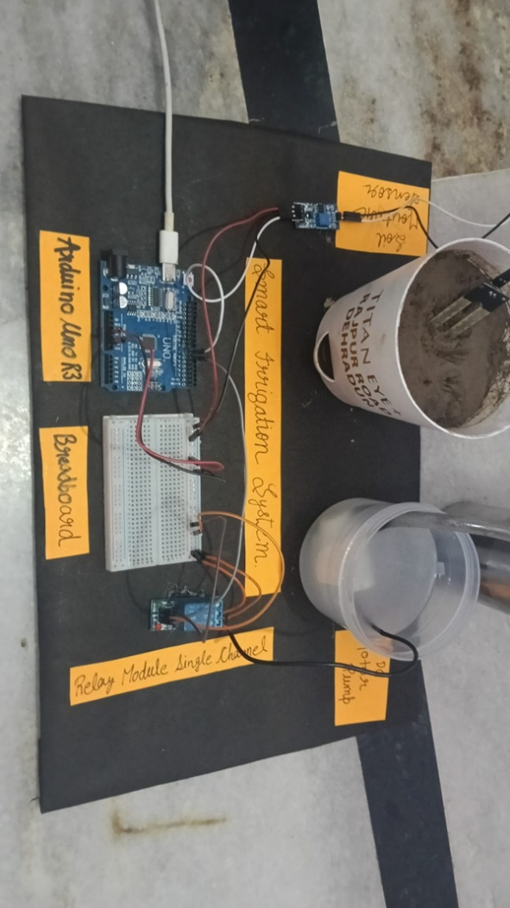
Pin Definitions (Code): -
const int soilMoisturePin = 7; // Soil moisture sensor digital pin

const int relayPin = 6; // Relay control pin

Variables
int soilMoistureState = 0;// Soil moisture digital reading
bool pumpState = false; // Current pump state

void setup() {
// Initialize Serial Monitor
Serial.begin(9600);
Serial.println("Smart Irrigation System Started");
Serial.println("================================");
Serial.println("Pin 6: Relay (Motor Control)");
Serial.println("Pin 7: Soil Moisture Sensor");
Serial.println("================================");

// Set pin modes
pinMode(soilMoisturePin, INPUT); // Soil sensor as input
pinMode(relayPin, OUTPUT); // Relay as output

// Initial state - pump OFF
digitalWrite(relayPin, LOW);
pumpState = false;

delay(2000); // Wait for sensor to stabilize
}

void loop() {
// Read soil moisture sensor (Digital)
// Most sensors: LOW = Wet soil, HIGH = Dry soil
soilMoistureState = digitalRead(soilMoisturePin);

// Display readings on Serial Monitor
Serial.print("Soil Moisture Sensor: ");

if (soilMoistureState == HIGH) {
// Soil is DRY - Turn pump ON
Serial.print("DRY (HIGH) | ");
digitalWrite(relayPin, HIGH);
pumpState = true;
Serial.println("Motor/Pump: ON - Watering...");

} else {
// Soil is WET - Turn pump OFF
Serial.print("WET (LOW) | ");
digitalWrite(relayPin, LOW);
pumpState = false;
Serial.println("Motor/Pump: OFF - Sufficient moisture");
}

delay(2000); // Check every 2 seconds
}

HOW IT WORKS: -
- Digital Soil Moisture Sensor:
- Output HIGH (1) when soil is DRY
- Output LOW (0) when soil is WET

- Relay Module:
- HIGH signal activates relay (motor ON)
- LOW signal deactivates relay (motor OFF)

- System Logic:
- Sensor detects dry soil → Sends HIGH to Pin 7
- Arduino sends HIGH to Pin 6 → Relay activates
- Motor/Pump turns ON → Waters the plant
- Soil becomes wet → Sensor sends LOW to Pin 7
- Arduino sends LOW to Pin 6 → Relay deactivates
- Motor/Pump turns OFF → Watering stops

IMPORTANT NOTES: -
- Pin 6: Controls the relay module (and thus the motor)
- Pin 7: Reads soil moisture sensor status
- Adjust sensor potentiometer to set sensitivity
- Use external power for motor if it draws >500mA
- Make sure relay can handle your motor's voltage/current

CALIBRATION: -
- Turn the potentiometer on the soil moisture sensor
- Clockwise = Less sensitive (triggers at drier soil)
- Counter-clockwise = More sensitive (triggers at wetter soil)
- Test by inserting sensor in dry/wet soil and checking LED on sensor

TROUBLESHOOTING: -
- If motor doesn't run: Check external power supply connection
- If motor runs continuously: Adjust sensor potentiometer
- If readings inverted: Some sensors have inverted logic
- Open Serial Monitor (9600 baud) to see real-time status
Application: -
- Agriculture
- Automatic crop irrigation in farms.
- Reduces labor and water usage (up to 40%).

- Greenhouses
- Maintains controlled moisture levels for delicate plants.

- Home Gardening
- Useful for pots, rooftop gardens, and small nurseries.

- Smart Cities / IoT Projects
- Lawn irrigation in parks using IoT control.
- Integration with weather-based watering systems.

- Precision Farming
- Used in modern agriculture to monitor soil health and optimize watering cycles.
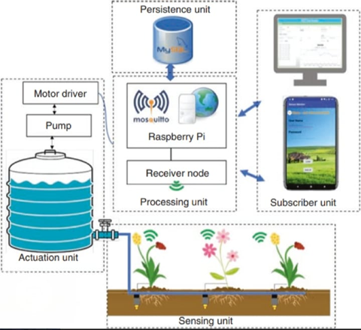
Reference:https://youtu.be/bJIriNF0zcA?si=Pzr6Gw3DD3gJOM4_

Advantages: -
- Saves water and electricity.
- Reduces human effort.
- Prevents over-irrigation (root rot) and under-irrigation (drying).
- Low cost and easy to implement.
- Highly customizable for different crops/climates.

Conclusion: -
A Smart Irrigation System using Arduino Uno is an efficient microcontroller-based solution that automates the watering process, improves water usage efficiency, and supports sustainable agriculture. With simple sensors and relays, the system becomes highly reliable, cost-effective, and suitable for farms, gardens, and IoT-based smart city applications.

For the construction of this model the refrences are :-
https://youtu.be/bJIriNF0zcA?si=Pzr6Gw3DD3gJOM4_

